Title
Distributed Sensor Network Analysis Using the Substitution Method
Aim
To solve the recurrence relation
$$T\left(n\right)=3T\left(n/3\right)+1$$
using the Substitution Method and determine its time and space complexity.
Algorithm
- Read the input size $n$.
- If $n=1$, return the base value.
- Divide the problem into three equal subproblems.
- Solve each recursively.
- Add constant work.
- Display the recurrence value, recursion depth, execution time, time complexity, and space complexity.
Recurrence Relation
$$T\left(n\right)=3T\left(n/3\right)+1$$
Where:
- Number of recursive calls ($a$) = 3
- Division factor ($b$) = 3
- Extra work $f\left(n\right)=1$
Solution Using the Substitution Method
Expand the recurrence:
$$T\left(n\right)=3T\left(n/3\right)+1 \\ =3\left(3T\left(n/9\right)+1\right)+1 \\ =9T\left(n/9\right)+4$$
After $k$substitutions: $T\left(n\right)=3^{k}T\left(n/3^{k}\right)+\sum_{i=0}^{k-1}{3^{i}}$
Using the geometric series: $T\left(n\right)=3^{k}T\left(n/3^{k}\right)+\frac{3^{k}-1}{2}$
When $n/3^{k}=1$, $k=\log_{3}n$
Substituting: $T\left(n\right)=nT\left(1\right)+\frac{n-1}{2}$
Thus, $T\left(n\right)=Θ\left(n\right)$
Complexity Analysis
Parameter | Value
Technique | Divide and conquer
Solving Method | Substitution Method
Time Complexity | Θ(n)
Space Complexity | Θ(log₃n)
Recursion Depth | log₃n

Performance Analysis
Input (n) | Recursion Depth | Time Complexity | Space Complexity
3 | 1 | Θ(n) | Θ(log₃n)
9 | 2 | Θ(n) | Θ(log₃n)
27 | 3 | Θ(n) | Θ(log₃n)
81 | 4 | Θ(n) | Θ(log₃n)
243 | 5 | Θ(n) | Θ(log₃n)

Input: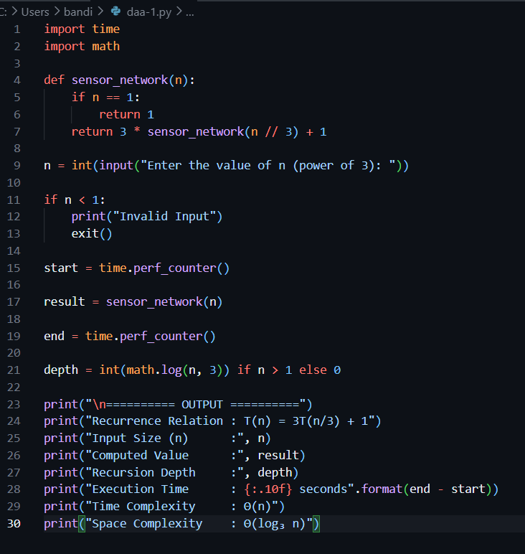
Output:
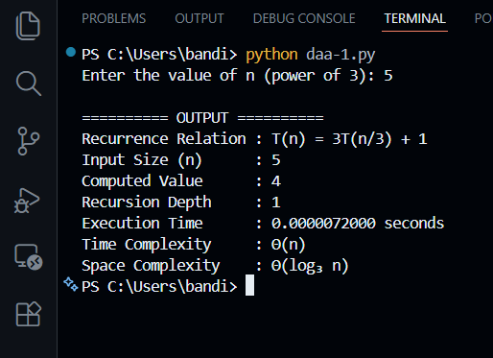
Applications
- Wireless Sensor Networks
- IoT Monitoring Systems
- Environmental Data Collection
- Distributed Surveillance Systems
Result
The recurrence relation $T\left(n\right)=3T\left(n/3\right)+1$was solved using the Substitution Method. The algorithm has linear time complexity $Θ\left(n\right)$and logarithmic auxiliary space complexity $Θ\left(\log_{3}n\right)$due to recursion.

